**CSCI 360 2. Editing in ISPF**

**X**

It is first important to know that names of entities on the mainframe can have 1 to 8 characters. They can only contain letters A-Z (upper case only), digits 0-9, and international characters $, # and @ (dollar sign, pound sign/hash tag, and at sign). They can only begin with a letter or one of the three international characters. Please do NOT use the international characters in this class.

It is also useful while editing in ISPF to press Caps Lock as 99.9% of everything you type in ISPF will need to be in capital letters.

1. To edit a PDS member:

From the ISPF Primary Option Menu select Option 2 (Edit). Then, on the Edit Entry Panel, type the name of the new member you want want to create and press Enter.

Or to begin editing an already existing member in a PDS:

Follow the same instructions from above or you can press Enter in the Edit Entry Panel and move the cursor to the dot across from the name of the member you wish to edit and type either s, S, e, or E and press Enter.

1. To save a member you are editing:

Type the word save or SAVE anywhere on the command line (Command ===>).

It is recommended that you save the member often as there is no autosave in ISPF!

Please note that items C through G below are usable on most panels in ISPF.

1. To exit a panel:

Use F3 to exit and back up one level.

Be sure that, if you are editing a PDS member, that you save it first!

1. To scroll up and down:

Use F7 for scrolling up and F8 for scrolling down.

1. To scroll left or right:

Use F10 to scroll left and F11 to scroll right.

1. To go to the top or bottom:

Type the word top or TOP on the command line to go to the top of the panel or type the word bot or BOT or bottom or BOTTOM to go to the end.

1. Setting the Scroll ===> value:

It is strongly suggested that you change Scroll ===> PAGE to Scroll ===> CSR on every panel that you can in ISPF. ISPF will retain this setting if you exit the panel normally. See lower right hand corner of Figure 1.

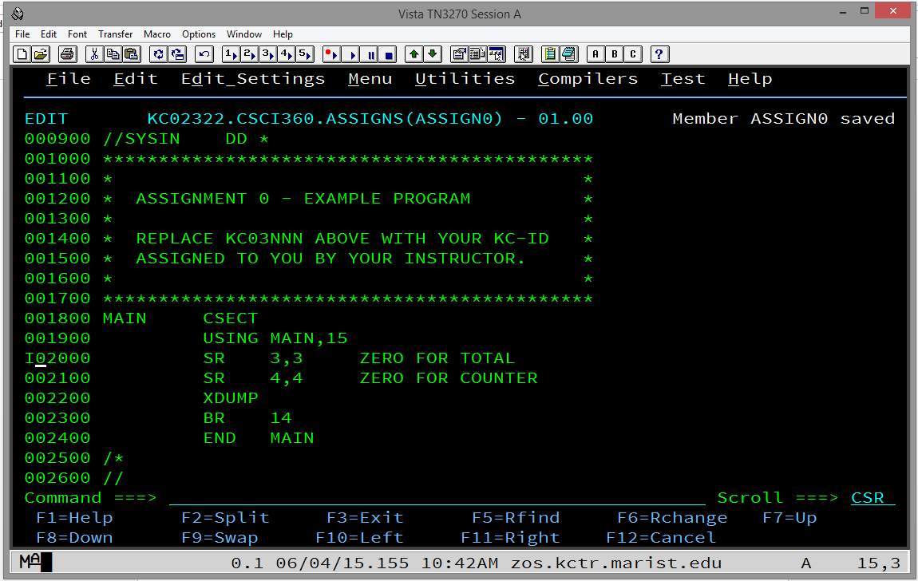

Figure 1.

1. To insert a line while editing:

Move the cursor with the tab key or your mouse to the line numbers on the left hand side of the screen and anywhere within those 6 digits type the letter i or I. See Figure 1. Press Enter to have the line inserted. See Figure 2.

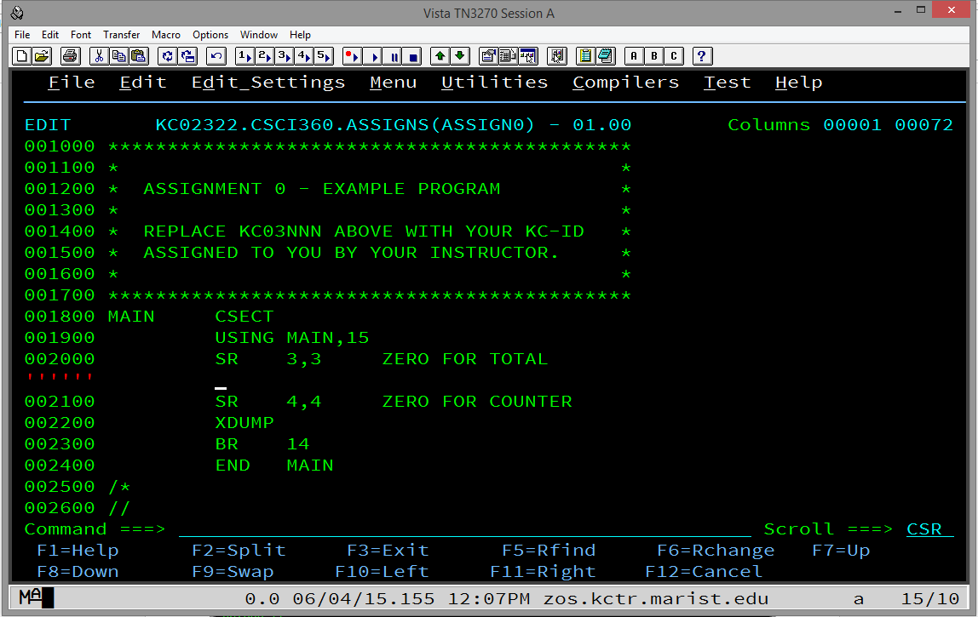

Figure 2.

1. To insert multiple lines while editing:

Do the above but follow the letter i or I with an integer between 2 and n. It will insert the number of lines you have requested but it will not scroll to show all of your inserted lines. It will fit as many on the panel as it can depending on where you began inserting the lines.

Note that, if you hit enter at this point, any lines that do not at least have a space (one press of the space bar on our keyboard) will simply be deleted.

Also, if you insert a line and type something on it, a new blank line with be automatically inserted if you press Enter.

1. To delete a line while editing:

Move the cursor with the tab key or your mouse to the line numbers on the left hand side of the screen and anywhere within those 6 digits type the letter d or D. See Figure 3. Press Enter to have the line deleted.

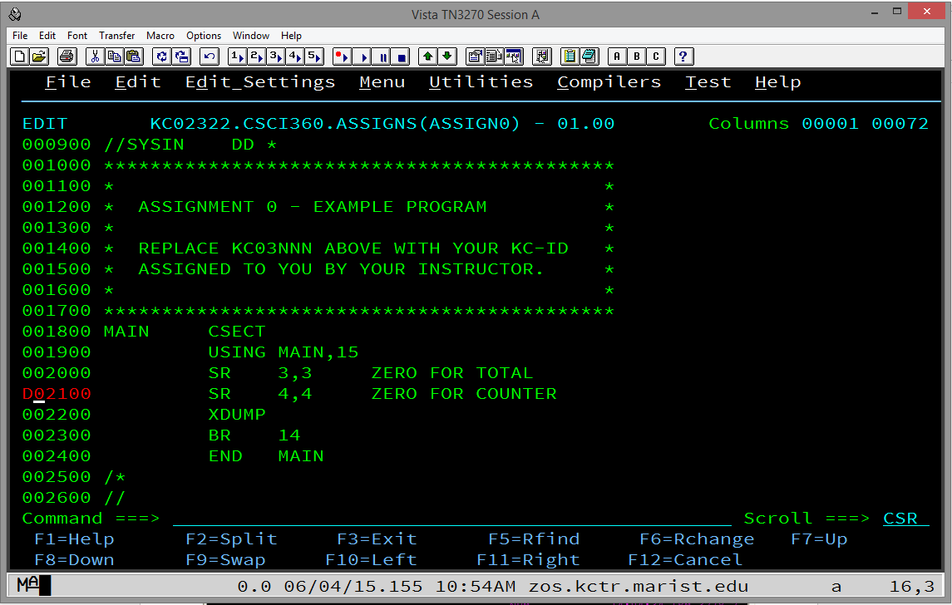

Figure 3.

1. To move a line while editing:

Move the cursor with the tab key or your mouse to the line numbers on the left hand side of the screen and anywhere within those 6 digits type the letter m or M. Then, move the cursor with the tab key or your mouse to where you want the line moved and type either a or A for inserting the line you are moving after the line where your cursor is or type either b or B for inserting the line you are moving before the line where your cursor is.

Note that you can scroll up or down with F7 or F8, respectively, and also use the command line top or bot to go to the top or bottom of the panel while the move is still active.

Also note that, when you start a move, you must complete it before you can go on editing. In other words, if you change your mind, you will still have to move the line but you can then delete it if necessary.

1. To copy a line while enditing:

Move the cursor with the tab key or your mouse to the line numbers on the left hand side of the screen and anywhere within those 6 digits type the letter c or C. Then, move the cursor with the tab key or your mouse to where you want the line copied and type either a or A for inserting the line you are moving after the line where your cursor is or type either b or B for inserting the line you are moving before the line where your cursor is.

1. Deleting, moving or copying blocks, or multiple lines while editing:

To delete a block of contiguous lines, type dd or DD on the first line you want to delete and type dd or DD on the last line you want to delete. These two lines and every line in between will be deleted.

To move a block, use mm or MM on both the first line and the last line you want to move and the a or A for after or b or B for before as in item K above. The block of contiguous lines will be deleted from its original place.

To copy a block, use cc or CC on both the first line and the last line you want to copy and the a or A for after or b or B for before as in item K above. The block of contiguous lines will remain in its original place and a copy will be inserted where you indicated it to be inserted.

1. To split a line of text:

To move the end of a line to the next line, or split the text, move the cursor with the tab key or your mouse to the line numbers on the left hand side of the screen and anywhere within those 6 digits type ts or TS for 'text split'. Then, before you press Enter, move your cursor to the character where you want to begin the split. See Figure 4.

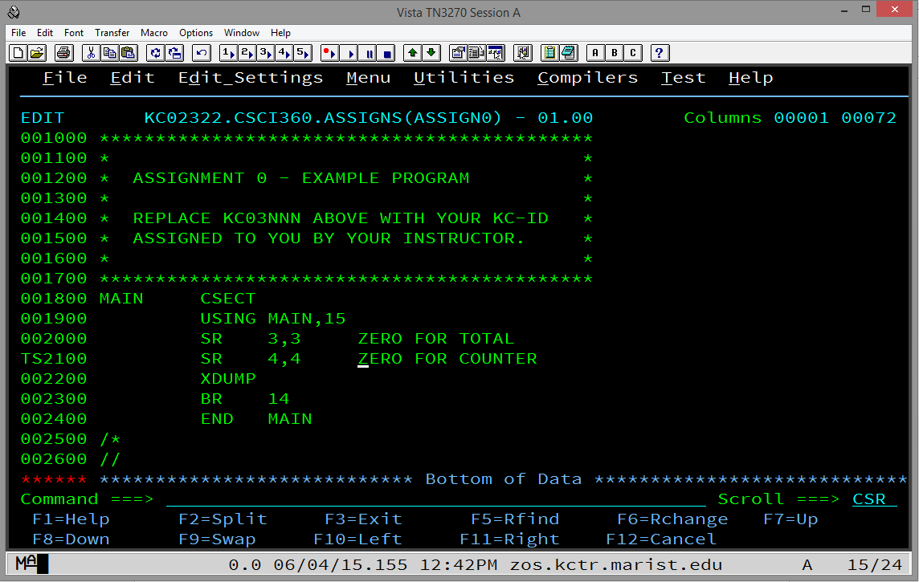

Figure 4.

Now, press Enter. Everything from the character you indicated as the beginning of the split will be pushed and inserted two lines down with a new line inserted in between. See Figure 5. Simply press Enter again and the new blank line will be removed.

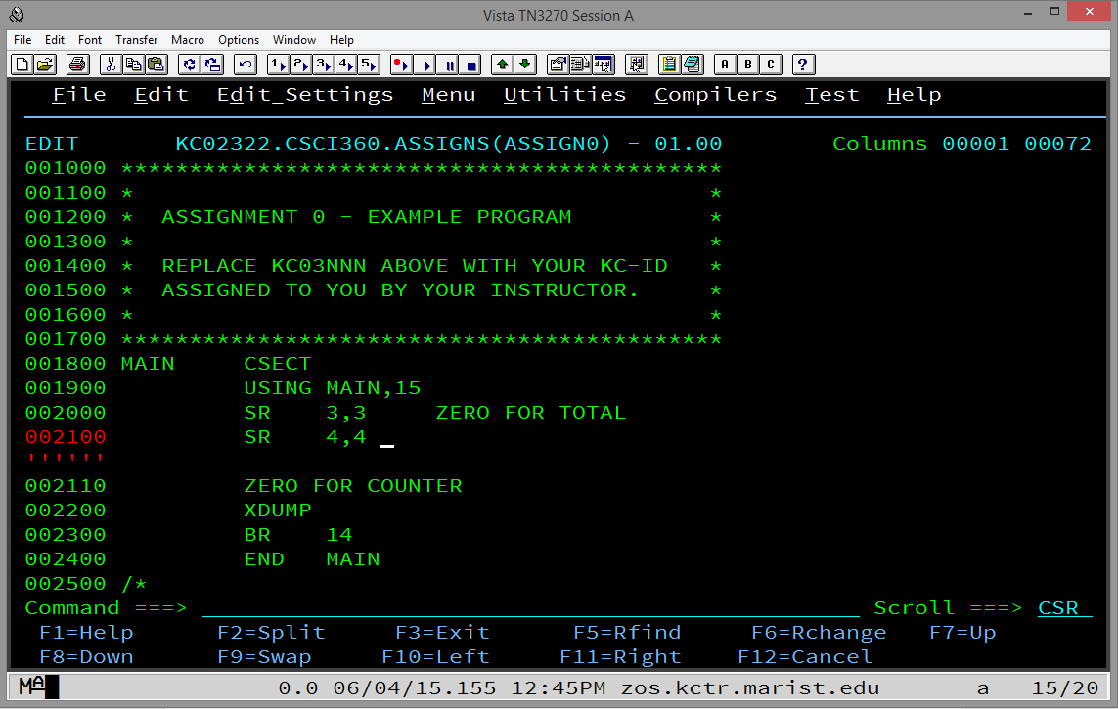

Figure 5.

1. To collapse (hide) lines while editing:

Because it is sometimes scrolling can be frustrating while editing, ISPF allows you to collapse lines. To collapse one or more lines, move the cursor with the tab key or your mouse to the line numbers on the left hand side of the screen and anywhere within those 6 digits type x or X to collapse one line or xn or Xn to collapse n lines.

To collapse a block, type xx or XX on the first line you want to collapse and scroll to the last line you want to collapse and type xx or XX. Press Enter and a dashed line will appear telling you how many lines are collapsed. See Figure 6.

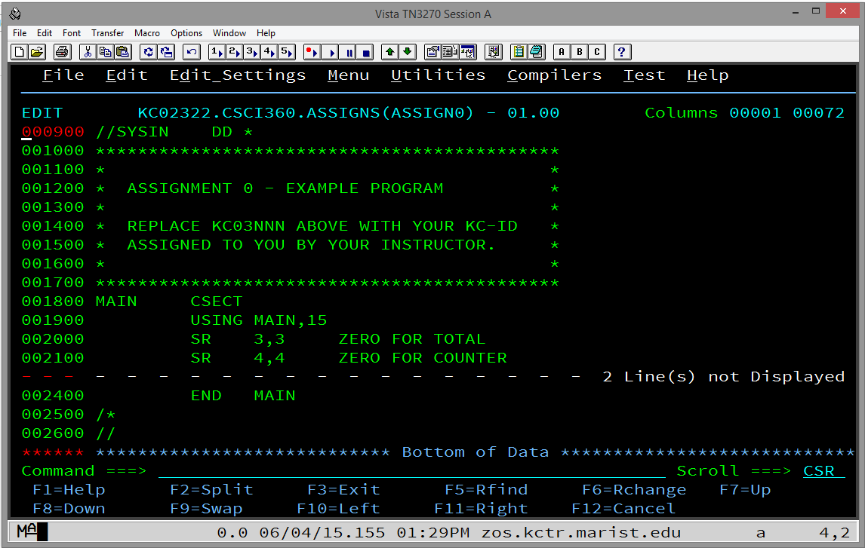

Figure 6.

If you collapse some lines but not enough, you can either type x or X and continue doing it but it is more efficient to move your cursor to the dashed line and type x or X or xn or Xn to collapse another line or another n lines, respectively.

1. To uncollapse (reveal) lines while editing:

Type res or RES or reset or RESET on the command line and press enter and all of the lines will be uncollapsed or revealed.

To uncollapse or reveal some lines but not others, go to the dashed line and type f or F to reveal the first collapsed line or fn or Fn to reveal the first n collapsed lines. You can also type l or L to reveal the last collapsed line or ln or Ln to reveal the last n collapsed lines.

**Some Basic ISPF Editing Commands**

**Basic Primary Editing Line Commands**

I/I*n* Insert one or *n* lines following this line.

D/D*n*/DD Delete this line, *n* lines beginning with this line, or the block of lines beginning and ending with DD.

R/R*n*/RR/RR*n* Repeat this line or the block of lines beginning and ending with RR one or *n* times.

C/Cn/CC Copy this line one or *n* times, or copy the block of lines beginning and ending with CC.

M/M*n*/MM Move this line one or *n* times, or move the block of lines beginning and ending with MM.

A/A*n* Copy or move lines one or *n* times after this line.

B/B*n* Copy or move lines one or *n* times before this line.

**Useful Primary Editing Primary Commands**

LOCATE *line-number* Moves to the indicated line.

FIND *string* Finds the first occurrence of *string*, starting from the current line. To find the next occurrence, press PF5.

CHANGE *string-1* *string-2* [ALL] Finds the first occurrence of *string-1*, starting from the current line, and changes it to *string-2*. To find the next occurrence, press PF5. To change the next occurrence, press PF6. To change all occurrences, include the ALL option.

COPY *member-name* Retrieves data from the specified member; use an A or B line command to specify where the data should be placed.

PROFILE Displays the profile settings for the edit session.

RECOVERY [ON | OFF] Determines whether edit recovery mode is on.

UNDO Reverses the last editing change.

SAVE Saves changes and continues the edit session.

END (PF3/15) Saves changes and returns to the Edit Entry panel.

RETURN (PF4/16) Saves changes and returns to the Primary Option Menu.

CANCEL Returns to the Edit Entry panel without saving changes.